Light System

(Controlled by smartphone)

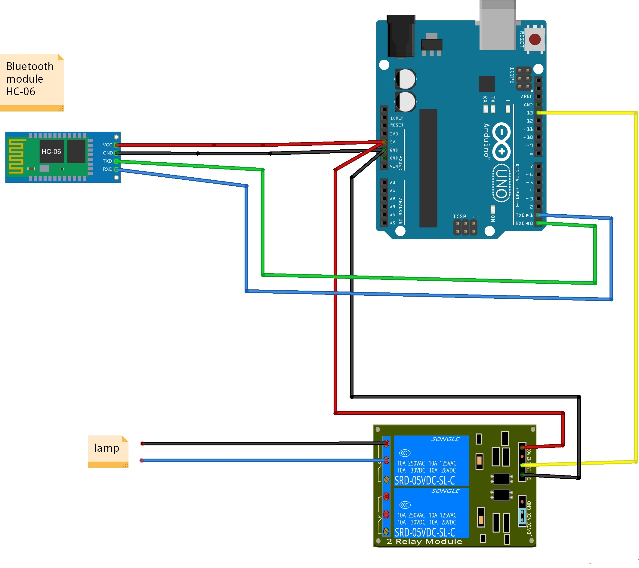

Circuit diagram-:

Theory-:

Concept Used-:

1. With bluetooth module light can be controlled.
2. Use of HC-05 Bluetooth module.
3. Use of external module.

LEARNING AND OBSERVATIONS:

• Connections in Breadboard and wiring.

• How to control arduino and its coding.

• Use of multimeter for continuity

OBSERVATION:

➢ Led controlled with bluetooth

➢ Relation between software and hardware

PROBLEMS & TROUBLESHOOTING:

o To select the right port and type of arduino

o To check the loose connections

o To check the connections according to the codes

o To check the continuity of the circuit

o To check the flow of current in the circuit

PRECAUTIONS:

o Handle Module carefully

o Do not connect arduino till the circuit is complete

OUTCOMES:

O Light blinking when pressed on from smartphone